Project Design Phase-II

Data Flow Diagram & User Stories

|  |  |
| --- | --- |
| Date | 18 October 2022 |
| Team ID | PNT2022TMID50117 |
| Project Name | News Tracking Application |
| Maximum Marks | 4 Marks |

# Data Flow Diagrams:

A Data Flow Diagram (DFD) is a traditional visual representation of the information flows within a system. A neat and clear DFD can depict the right amount of the system requirement graphically. It shows how data enters and leaves the system, what changes the information, and where data is stored.

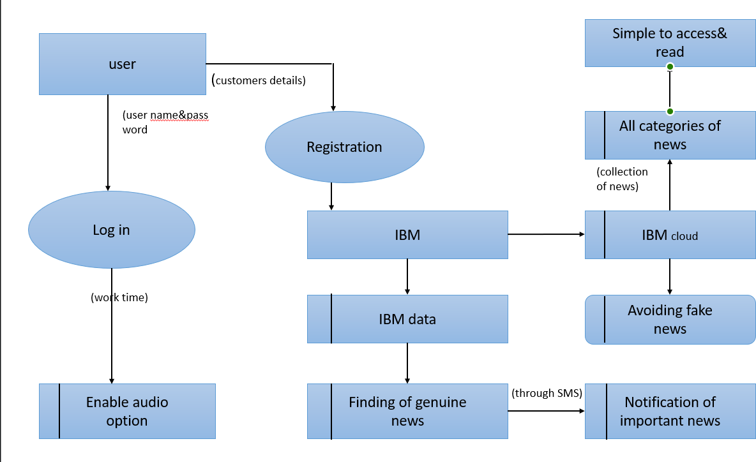

# User Stories

Use the below template to list all the user stories for the product.

|  |  |  |  |  |  |  |
| --- | --- | --- | --- | --- | --- | --- |
| **User Type** | **Functional Requirement (Epic)** | **User Story Number** | **User Story / Task** | **Acceptance criteria** | **Priority** | **Release** |
| Customer (Mobile user) | Registration | USN-1 | As a user, I can register for the application by entering my email, password, and confirming my password. | I can access my account / dashboard | High | Sprint-1 |
|  |  | USN-2 | As a user, I will receive confirmation email once I have registered for the application | I can receive confirmation email & click confirm | High | Sprint-1 |
|  |  | USN-3 | As a user, I can register for the application through Facebook | I can register & access the dashboard with Facebook Login | Low | Sprint-2 |
|  |  | USN-4 | As a user, I can register for the application through Gmail | I can access my account | Medium | Sprint-1 |
|  | Login | USN-5 | As a user, I can log into the application by entering email & password | I can receive confirmation email and password through email | High | Sprint-1 |
|  | Dashboard | USN-6 | As a user, I will able to see the login and profile details | I can able to login through Gmail account | Medium | Sprint-3 |
| Customer (Web user) | Registration | USN-7 | As a user, I can register for the application by entering my name, phone number, email, password, and confirming my password. | I can access my google account / dashboard | High | Sprint-1 |
| Customer Care Executive | Chat box | USN-8 | As a customer care executive, I can ask about the inconvenience and the usability about the app | I can access through IBM Watson | Medium | Sprint-4 |
| Administrator | Login | USN-9 | As a administrator, I can help to login and register the user through gmail | I can receive confirmation Gmail to user | High | Sprint-2 |
| NEWS Tracker | IBM cloud | USN-10 | As a tracker, I collect all the NEWS from the cloud | I can access the IBM Cloud | Medium | Sprint-1 |
| Database Manager | IBM DB2 | USN-11 | As a database manager, I can collect all the user details and NEWS application details | I can access the IMB Db2 | Medium | Sprint-3 |